November 2017 Jiangsu Yawei exhibition Express2017-10-21Yawei shares

Pay attention to us
The nineteenth China International Industrial Expo numerical control machine tool and metal processing exhibition will be held in Shanghai. Around the theme of "innovation, only and green", the exhibition shows the change of thought and manufacturing mode brought about by "China made 2025" and "intelligent manufacturing". At that time, we will carry three models to shock the appearance. Waiting for you to visit the booth yawei!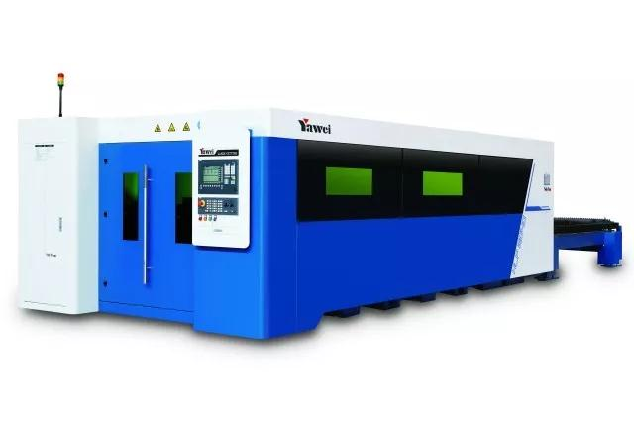
Time: 11 -11 month, November 7th
Address: National Convention and Exhibition Center (Shanghai)
Booth number: 2H F008
HLF-1530 laser cutting machine
The new appearance design, the performance is greatly improved, the new generation of high speed fiber laser cutting machine with the international level of shoulder;
Longmen double drive bed structure, high strength aluminum alloy crossbeam, high efficiency automatic exchange table, production capacity multiplied;
Thin plate ultra high speed cutting, medium and thick plate high efficiency processing, the metal material processing universality is better.
The advanced laser technology and advanced digital control technology are integrated in depth, and the humanized operation interface and the cutting expert parameter library are upgraded.
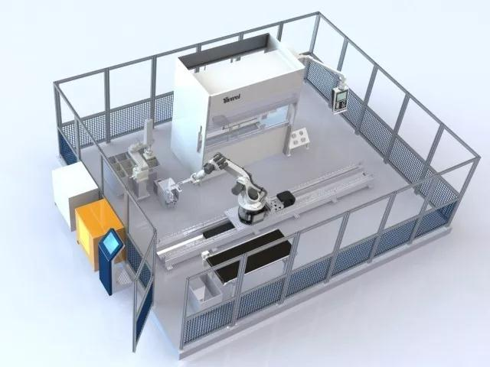
Small bending unit

PBE0102FMC0 is more suitable for automatic bending of small parts, and it can automatically complete many complex parts. It is convenient for programming and quick in operation.
Selection of Yahweh, the choice of excellent service:
- have Yawei series high - precision bending machine, high precision, can realize high precision robot, robot bending unit
The technical team has rich Yawei metal production experience, provide various schemes for your bending robot, you meet the processing requirements of complex products, heavy products
Automatic bending unit of small sheet material can easily realize 24 hours uninterrupted work, save labor and maximize profit.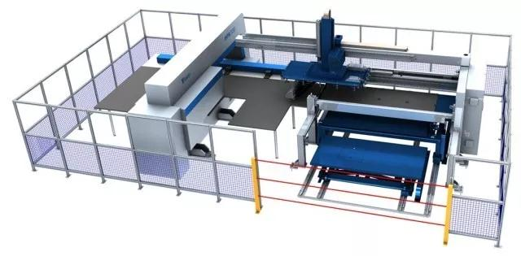
AMS.H-30510 NC sheet metal stamping processing system

The advanced control system integrates the functional units of various parts together effectively, making the efficiency of the plate processing to a new height.
Its performance features are as follows:
Reduce production cost, short production time, reduce manual operation and processing
To improve the quality of the parts and the high precision of the parts
Decrease material cost, efficient cutting, increase the utilization ratio of sheet
The production has high flexibility and high automation, and the mechanical hand of the material is used to butt the plate with the punch machine directly.


长按识别二维码关注我们

